# Task C.3

## Simple Reports

**Report 1**

1. **The query questions written in English**

Top 15 most rented property by scale and suburb.

1. **Your explanation on why such a query is necessary or useful for the management**

This will allow the management to get the sentiment of the rental market.

1. **The SQL commands**

SELECT s.scale_description as Scale,

a.suburb as Suburb,

SUM(f.number_of_rent) as Number_of_Rents,

ROW_NUMBER() OVER(ORDER BY SUM(f.number_of_rent) DESC) as RANK

FROM mre_rent_fact_l2 f, mre_scale_dim_l2 s, mre_property_dim_l2 p, mre_address_dim_l2 a

WHERE f.scale_id = s.scale_id

AND f.property_id = p.property_id

AND p.address_id = a.address_id

AND ROWNUM <= 16

GROUP BY s.scale_description, a.suburb

ORDER BY ROW_NUMBER() OVER(ORDER BY SUM(f.number_of_rent) DESC) ASC;

1. **The screenshots of the query results (or part of the query results), including all the attribute names**

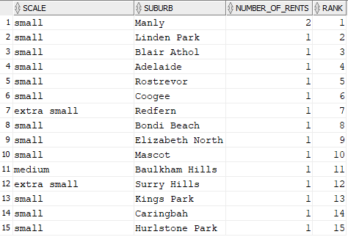

**Report 2**

1. **The query questions written in English**

Top 10% sales based on time period and property type.

1. **Your explanation on why such a query is necessary or useful for the management**

This might give the management an idea to focus on which suburb at what time to boast business performance.

1. **The SQL commands**

SELECT *

FROM (

SELECT t.year as Year,

t.month as Month,

p.property_type as Property_Type,

SUM(f.total_sales_price) as Total_Sales_Price,

SUM(f.number_of_sales) as Number_of_Sales,

PERCENT_RANK() OVER (ORDER BY SUM(f.total_sales_price) DESC) as Revenue_Ranking

FROM mre_sale_fact_l2 f, mre_property_dim_l2 p, mre_time_dim_l2 t

WHERE f.time_id = t.time_id

GROUP BY t.year, t.month, p.property_type)

WHERE Revenue_Ranking >= 0.85

ORDER BY Revenue_Ranking DESC;

1. **The screenshots of the query results (or part of the query results), including all the attribute names**

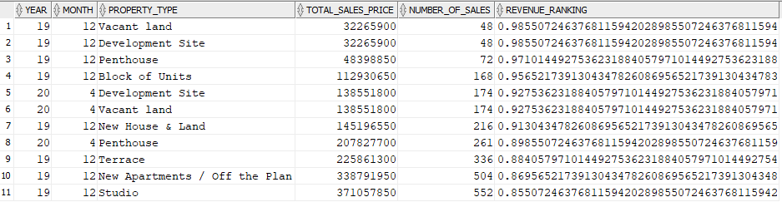

**Report 3**

1. **The query questions written in English**

Total property visited by suburb and season.

1. **Your explanation on why such a query is necessary or useful for the management**

This will give the management and insight of property investment of different locations and seasons

1. **The SQL commands**

SELECT t.year as Year,

s.season_description as season,

a.suburb as suburb,

SUM(number_of_visits) as Number_of_Visits

FROM mre_visit_fact_l0 f, mre_time_dim_l0 t,

mre_season_dim_l0 s, mre_property_dim_l0 p, mre_address_dim_l0 a

WHERE f.time_id = t.time_id

AND t.season_id = s.season_id

AND f.property_id = p.property_id

AND p.address_id = a.address_id

GROUP BY t.year, s.season_description, a.suburb

ORDER BY t.year, s.season_description,

a.suburb;

1. **The screenshots of the query results (or part of the query results), including all the attribute names**

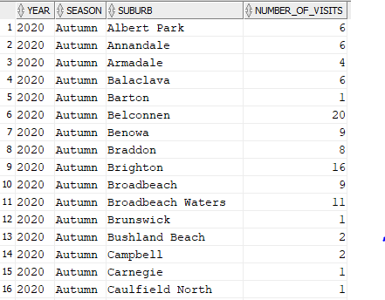

## Reports with proper sub-totals

**Report 4**

1. **The query questions written in English**

What are the sub-total and total rental fees from each suburb, time period, and property type?

1. **Your explanation on why such a query is necessary or useful for the management**

This will give the management an idea of different combinations between suburb, time period and property type.

1. **The SQL commands**

SELECT t.year||t.month as Time_Period,

a.suburb as Suburb,

p.property_type as Property_Type,

to_char(SUM(f.total_rent_fee), '9,999,999,999.99')

as Rental_Fees,

DECODE(GROUPING(t.year||t.month), 1, 'All Periods',

t.year||t.month) as Period,

DECODE(GROUPING(a.suburb), 1, 'All Suburbs',

a.suburb) as Suburbs,

DECODE(GROUPING(p.property_type), 1, 'All Types',

p.property_type) as Types

FROM mre_rent_fact_l2 f, mre_time_dim_l2 t, mre_property_dim_l2 p, mre_address_dim_l2 a

WHERE f.time_id = t.time_id

AND f.property_id = p.property_id

AND p.address_id = a.address_id

GROUP BY CUBE(t.year||t.month, a.suburb, p.property_type);

1. **The screenshots of the query results (or part of the query results), including all the attribute names**

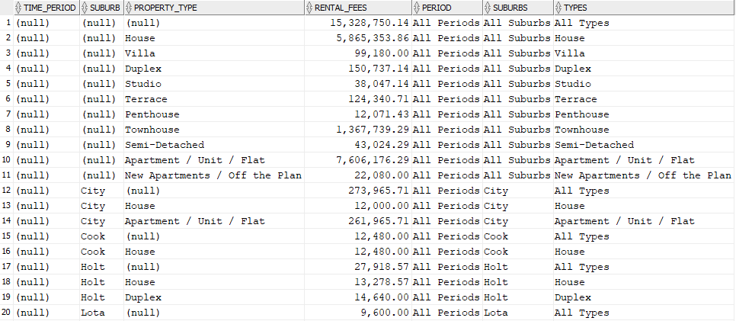

**Report 5**

1. **The query questions written in English**

What are the sub-total and total rental fees from each suburb, time period, and property type?

1. **Your explanation on why such a query is necessary or useful for the management**

This will give the management an idea of different combinations between suburb, time period and property type.

1. **The SQL commands**

SELECT t.year||t.month as Time_Period,

a.suburb as Suburb,

p.property_type as Property_Type,

to_char(SUM(f.total_rent_fee), '9,999,999,999.99')

as Rental_Fees,

DECODE(GROUPING(t.year||t.month), 1, 'All Periods',

t.year||t.month) as Period,

DECODE(GROUPING(a.suburb), 1, 'All Suburbs',

a.suburb) as Suburbs,

DECODE(GROUPING(p.property_type), 1, 'All Types',

p.property_type) as Types

FROM mre_rent_fact_l2 f, mre_time_dim_l2 t, mre_property_dim_l2 p, mre_address_dim_l2 a

WHERE f.time_id = t.time_id

AND f.property_id = p.property_id

AND p.address_id = a.address_id

GROUP BY a.suburb, CUBE(t.year||t.month,

p.property_type);

1. **The screenshots of the query results (or part of the query results), including all the attribute names**

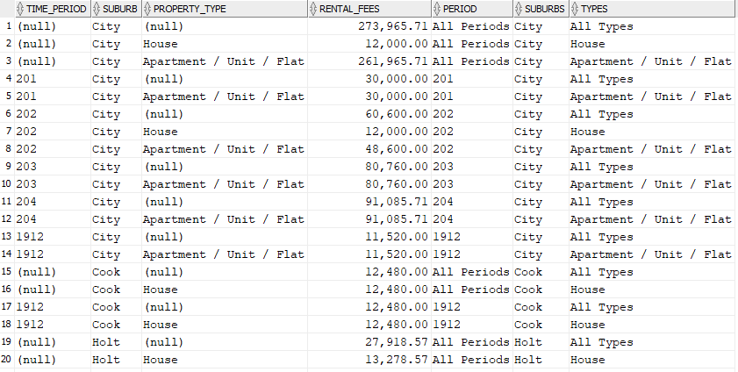

**Report 6**

1. **The query questions written in English**

What is the sub-total and total sale revenue from each state and time period for houses?

1. **Your explanation on why such a query is necessary or useful for the management**

This will give the management an understanding of sale of one of their best sellers, houses, at different states and time periods.

1. **The SQL commands**

SELECT t.year||t.month as Time_period,

st.state_name as State,

SUM(s.total_sales_price) as Total_Revenue,

DECODE(GROUPING(t.year||t.month), 1, 'All Periods',

t.year||t.month) as Periods,

DECODE(GROUPING(st.state_name), 1, 'All States',

st.state_name) as States

FROM mre_sale_fact_l2 s, mre_property_dim_l2 p,

mre_address_dim_l2 a, mre_postcode_dim_l2 pc,

mre_state_dim_l2 st, mre_time_dim_l2 t

WHERE s.property_id = p.property_id

AND p.address_id = a.address_id

AND a.postcode = pc.postcode

AND pc.state_code = st.state_code

AND s.time_id = t.time_id

AND p.property_type = 'House'

GROUP BY ROLLUP (t.year||t.month,

st.state_name);

1. **The screenshots of the query results (or part of the query results), including all the attribute names**

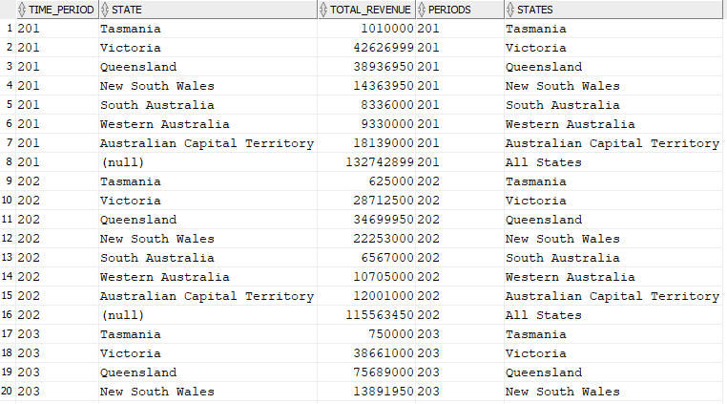

**Report 7**

1. **The query questions written in English**

What is the sub-total and total sale revenue from each state and time period for houses?

1. **Your explanation on why such a query is necessary or useful for the management**

This will give the management an understanding of sale of one of their best sellers, houses, at different states and time periods.

1. **The SQL commands**

SELECT t.year||t.month as Time_period,

st.state_name as State,

SUM(s.total_sales_price) as Total_Revenue,

DECODE(GROUPING(t.year||t.month), 1, 'All Periods',

t.year||t.month) as Periods,

DECODE(GROUPING(st.state_name), 1, 'All States',

st.state_name) as States

FROM mre_sale_fact_l2 s, mre_property_dim_l2 p, mre_address_dim_l2 a, mre_postcode_dim_l2 pc, mre_state_dim_l2 st, mre_time_dim_l2 t

WHERE s.property_id = p.property_id

AND p.address_id = a.address_id

AND a.postcode = pc.postcode

AND pc.state_code = st.state_code

AND s.time_id = t.time_id

AND p.property_type = 'House'

GROUP BY st.state_name, ROLLUP

(t.year||t.month);

1. **The screenshots of the query results (or part of the query results), including all the attribute names**

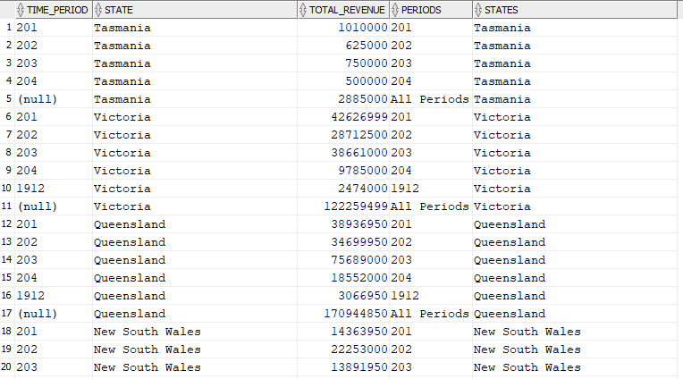

## Reports with moving and cumulative aggregates

**Report 8**

1. **The query questions written in English**

What is the total number of clients and cumulative number of clients with a high budget in each year?

1. **Your explanation on why such a query is necessary or useful for the management**

This will give the management an understanding of how high budget clients have chosen MonRE as their preferred agency.

1. **The SQL commands**

SELECT year,

SUM(total_clients) as Number_of_Clients,

SUM(SUM(total_clients)) OVER (ORDER BY year ROWS

UNBOUNDED PRECEDING) as Cumulative_Total

FROM

(SELECT *

FROM

(SELECT t.year, SUM(f.number_of_clients) as total_clients

FROM mre_client_fact_l0 f, mre_budget_dim_l0 b, mre_rent_fact_l0 rf, mre_time_dim_l0 t

WHERE f.budget_id = b.budget_id

AND f.client_person_id = rf.client_person_id

AND rf.rent_start_date = t.time_id

AND b.budget_description LIKE 'High%'

GROUP BY t.year)

UNION

(SELECT t.year, SUM(f.number_of_clients) as total_clients

FROM mre_client_fact_l0 f, mre_budget_dim_l0 b, mre_sale_fact_l0 sf, mre_time_dim_l0 t

WHERE f.budget_id = b.budget_id

AND f.client_person_id = sf.client_person_id

AND sf.time_id = t.time_id

AND b.budget_description LIKE 'High%'

GROUP BY t.year))

GROUP BY year

ORDER BY year;

1. **The screenshots of the query results (or part of the query results), including all the attribute names**

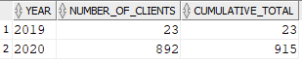

**Report 9**

1. **The query questions written in English**

What is the total monthly number of visits and 3-month average number of visits?

1. **Your explanation on why such a query is necessary or useful for the management**

Management may want to know more about why are there more visits in certain months. They can then drill down to find out which properties are having many visits from different visiting clients.

1. **The SQL commands**

SELECT t.year,

t.month,

number_of_visit as Number_of_Visits,

to_char(AVG(SUM(f.number_of_visit)) OVER (ORDER BY

t.year, t.month ROWS 2 PRECEDING), '99') as

Average_3_Month_Visits

FROM mre_visit_fact_l2 f, mre_time_dim_l2 t

WHERE f.visit_time_id =t.time_id

GROUP BY t.year, t.month, number_of_visit

ORDER BY year, month +0;

1. **The screenshots of the query results (or part of the query results), including all the attribute names**

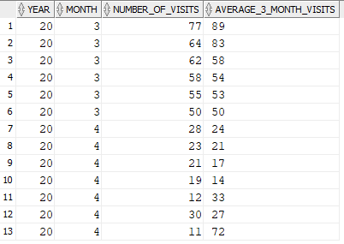

**Report 10**

1. **The query questions written in English**

Cumulative monthly total number of rents based on properties that have been rented to clients.

1. **Your explanation on why such a query is necessary or useful for the management**

Management would have a good indication of cash flow coming from rentals. They can use this information to make decisions on whether to increase spending on attracting tenants.

1. **The SQL commands**

SELECT t.year as Year,

t.month as Month,

SUM(Number_of_Rent) as Number_of_Rents,

SUM(SUM(number_of_rent)) OVER (ORDER BY t.year,

t.month ROWS UNBOUNDED PRECEDING) as

Cumulative_Number_of_Rent

FROM mre_rent_fact_l2 f, mre_time_dim_l2 t

WHERE f.time_id = t.time_id

GROUP BY t.year, t.month

ORDER BY year, month +0;

1. **The screenshots of the query results (or part of the query results), including all the attribute names**

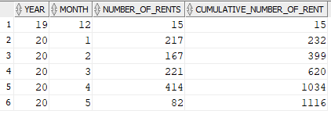

## Reports with Partitions

**Report 11**

1. **The query questions written in English**

Show ranking of each property type based on the yearly total number of sales and the ranking of each state based on the yearly total number of sales.

1. **Your explanation on why such a query is necessary or useful for the management**

This information might to useful to management to see the property type with most sales as well as the state with most sales of each type.

1. **The SQL commands**

SELECT t.year as Year,

p.property_type as Property_Type,

s.state_name as State,

SUM(f.number_of_sales) as Total_Number_of_Sales,

RANK() OVER (PARTITION BY t.year ORDER BY

SUM(f.number_of_sales) DESC) as RANK_BY_YEAR,

RANK() OVER (PARTITION BY s.state_name ORDER BY

SUM(f.number_of_sales) DESC) as RANK_BY_STATE

FROM mre_sale_fact_l2 f, mre_property_dim_l2 p,

mre_time_dim_l2 t, mre_address_dim_l2 a, mre_postcode_dim_l2 pc, mre_state_dim_l2 s

WHERE f.property_id = p.property_id

AND f.time_id = t.time_id

AND p.address_id = a.address_id

AND a.postcode = pc.postcode

AND pc.state_code = s.state_code

GROUP BY t.year, p.property_type, s.state_name

ORDER BY SUM(f.number_of_sales) DESC;

1. **The screenshots of the query results (or part of the query results), including all the attribute names**

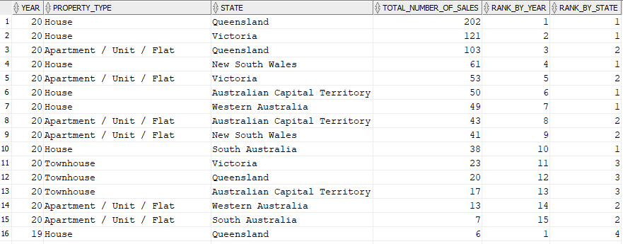

**Report 12**

1. **The query questions written in English**

Show ranking of each advertisement type based on the yearly total number of adverts and the ranking of each state based on the yearly total number of adverts.

1. **Your explanation on why such a query is necessary or useful for the management**

This information might be useful to management to compare the number of advertisements of different types and different states to observe sale patterns of certain areas.

1. **The SQL commands**

SELECT t.year as Year,

ad.advert_name as Advertisement_Type,

s.state_name as State,

SUM(f.number_of_adverts) as

Yearly_Total_Number_of_Adverts,

RANK() OVER (PARTITION BY ad.advert_name ORDER BY

SUM(f.number_of_adverts) DESC) as

RANK_BY_ADVERT_TYPE,

RANK() OVER (PARTITION BY s.state_name ORDER BY

SUM(f.number_of_adverts) DESC) as RANK_BY_STATE

FROM mre_advert_fact_l0 f, mre_advertisement_dim_l0 ad, mre_property_dim_l0 p, mre_address_dim_l0 a, mre_postcode_dim_l0 pc, mre_state_dim_l0 s, mre_time_dim_l0 t

WHERE f.advert_id = ad.advert_id

AND f.property_id = p.property_id

AND p.address_id = a.address_id

AND a.postcode = pc.postcode

AND pc.state_code = s.state_code

AND f.time_id = t.time_id

GROUP BY t.year, ad.advert_name, s.state_name

ORDER BY SUM(f.number_of_adverts) DESC;

1. **The screenshots of the query results (or part of the query results), including all the attribute names**

